Choose the letter of the answer to each problem. In all cases, NOTA means “none of these answers.

- George’s cranky old grandma wants her tea! When George asks her how much sugar she wants in her tea, Grandma replies, “I want x spoonfuls of sugar, given that 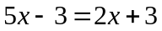.” How many spoonfuls of sugar does Grandma want in her tea?

- -3 B) -1 C) 2 D) 3 E) NOTA

- Find the median of the following data set: 3, 1, 2, 5, 4, 3, 2.

A) 1 B) 2 C) 3 D) 4 E) NOTA

- Evaluate: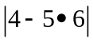.
- -26 B) -6 C) 6 D) 26 E) NOTA

- Simplify: 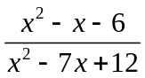.
- 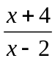 B) 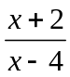 C) 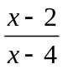 D) cannot be simplified

E) NOTA

- George needs to go from the kitchen to the bathroom. Suppose that the layout of George’s house is on a Cartesian coordinate plane. The kitchen is located at (1, 2) and the bathroom is located at (4, 6). How far does George need to travel to get from the kitchen to the bathroom? (For the purposes of this question, assume that George lives in a one-story house.)

A) 3 B) 5 C) 6 D) 7 E) NOTA

- What is the slope of a line that passes through the points (7, 4) and (-11, 21)?
- 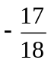 B) 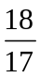 C) 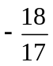 D)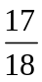 E) NOTA

- If a☺b = 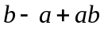, what is (4☺2)☺3?

A) 9 B) 12 C) 15 D) 18 E) NOTA

- George is trying to get into the shed next to the henhouse. However, he finds that there is a lock on the door! Taped to the door is a note: “One must enter the secret number if they wish to gain entry. This number is the answer to the following question: the sum of two numbers is 86. The larger of the two numbers is six more than four times the smaller number. Find the product of the two numbers.” What number should George enter to gain entry to the shed?

A) 864 B) 1026 C) 1120 D) 1264 E) NOTA

- Upon entering the shed (assuming George got the last question right), George finds a huge bottle with purple pills in it. The number of pills he ends up putting in his pot of soon-to-be marvelous medicine equals “six added to the square of the difference of seven and x.” Which of the following statements correctly represents this expression?

- 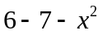 B) 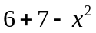 C) 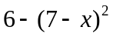 D) 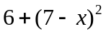 E) NOTA

- Find the value of the following expression: 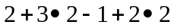.

A) 7 B) 11 C) 18 D) 22 E) NOTA

- If 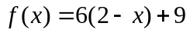, find 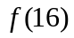.

A) -85 B) -75 C) 75 D) 95 E) NOTA

- Simplify the following: 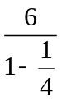

A) 4 B) 6 C) 8 D) 12 E) NOTA

- George’s father is getting ready to go home after a long day of work. He starts at the point (1, 2), drives 4 units to the left, then drives 8 units down, ending at the point (-3, -6). Find the midpoint between his starting and ending points.

A) (-4, -2) B) (-2, -4) C) (-1, -2) D) (2.5, 5) E) NOTA

- Express 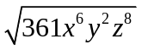in simplest terms. Assume x, y, and z are all positive numbers.

- 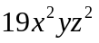 B) 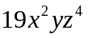 C) 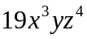 D) 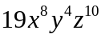 E) NOTA

- What is the greatest common factor of 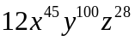and 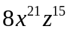?
- 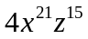 B) 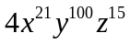 C) D) 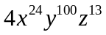

E) NOTA

- George’s dad is now driving along the line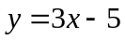. George’s mom (who is also on her way home) has just passed the point (6, 2), and is driving on a line that happens to be perpendicular to the path of George’s dad. Find the equation of the line, in slope-intercept form, along which George’s mom is driving.
- 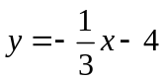 B) 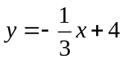 C) 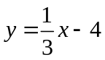 D) 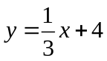

E) NOTA

- George’s family owns a combined total of 12 chickens and pigs. They have two more chickens then they have pigs. Added together, the two species of animals have a combined total of 34 legs. How many chickens do they have?

A) 2 B) 5 C) 6 D) 7 E) NOTA

- Given that 20% of x equals 40% of y, find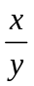.
A) 1 B) 2 C) 4 D) 8 E) NOTA

- George started out with 100 cups of marvelous medicine. However, after giving some to all of the animals at the farm, he has used 66 cups of medicine. What percent of his original amount of marvelous medicine does George have left?

A) 34% B) 36% C) 64% D) 66% E) NOTA

- Express the following using only positive exponents: 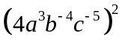.

- 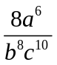 B) 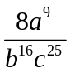 C) 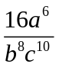 D) 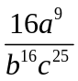 E) NOTA

- George wants to make some more marvelous medicine, but he’s run out of ingredients! Thinking quickly, his dad speeds off to the supermarket to buy some more ingredients. If he needs 80 dollars to buy a bottle of Flowers of Turnips perfume (it’s expensive stuff), and he makes 5 dollars an hour by selling eggs every day at the market, how many hours must George’s dad work in order to buy the bottle of perfume if he already has 10 dollars?

A) 14 hours B) 16 hours C) 17 hours D) 18 hours E) NOTA

- Solve for x in terms of the other three variables: 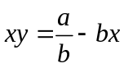
- 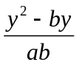 B) 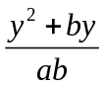 C) 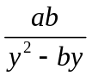 D) 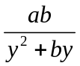 E) NOTA

- Oops! It turns out that George forgot to mention some of the other ingredients that he had used in his first marvelous medicine. Once again, George’s father rushes off to the supermarket, wallet in hand. He spends of the money in his wallet to buy a box of flea powder. He then spends of the remanding money in his wallet to buy some brown shoe polish, leaving him with 4 dollars. How much money did George’s dad have in his wallet before he bought the flea powder and shoe polish?

A) 12 dollars B) 15 dollars C) 18 dollars D) 21 dollars E) NOTA

- Solve for x: 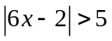.
- 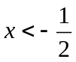 B) 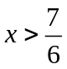 C) AND D) OR E) NOTA

- At 7:00 A.M., George suddenly remembers that he also used engine oil in Marvelous Medicine One. The nearest store that sells engine oil, however, happens to be miles away. Upon hearing this, George’s dad jumps into his spiffy new car and starts driving towards the store at a rate of 20 mph. Three hours later, George suddenly remembers that he also used antifreeze, and starts chasing after his dad in a second car at 40 mph. At what time will George catch up to his dad (round to the nearest minute if necessary)?

A) 11:00 A.M. B) 12:00 P.M. C) 12:30 P.M. D) 1:00 P.M

E) NOTA

- Given that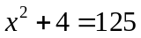, find all values for x that make the equation true.

A) -11 only B) 11 only C) -11, 11 D) no solution E) NOTA

- A line has a slope of 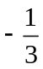. Find the slope of a line parallel to this line.

- -3 B) C) D) 3 E) NOTA

- If 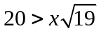, which of the following values could be x?

A) 4 B) 5 C) 6 D) 7 E) NOTA

- George’s Grandma is really old. In fact, Grandma is 54 years older than George’s mom. Mom is 4 times as old as George. George is 78 years younger than Grandma. How old is Grandma?

A) 82 B) 86 C) 89 D) 92 E) NOTA

- The number of cats there are in town at any given time is directly proportional to the number of rats there are in town. If there are 60 cats and 20 rats in town right now, how many cats would be in town if there were 30 rats in town?

A) 65 B) 70 C) 75 D) 80 E) NOTA

